Bennett Amoah

SQL Assignment

Imported the SQL Script "world db" and then executed the script. After that, I refreshed the schemas and checked if the database "world" existed.

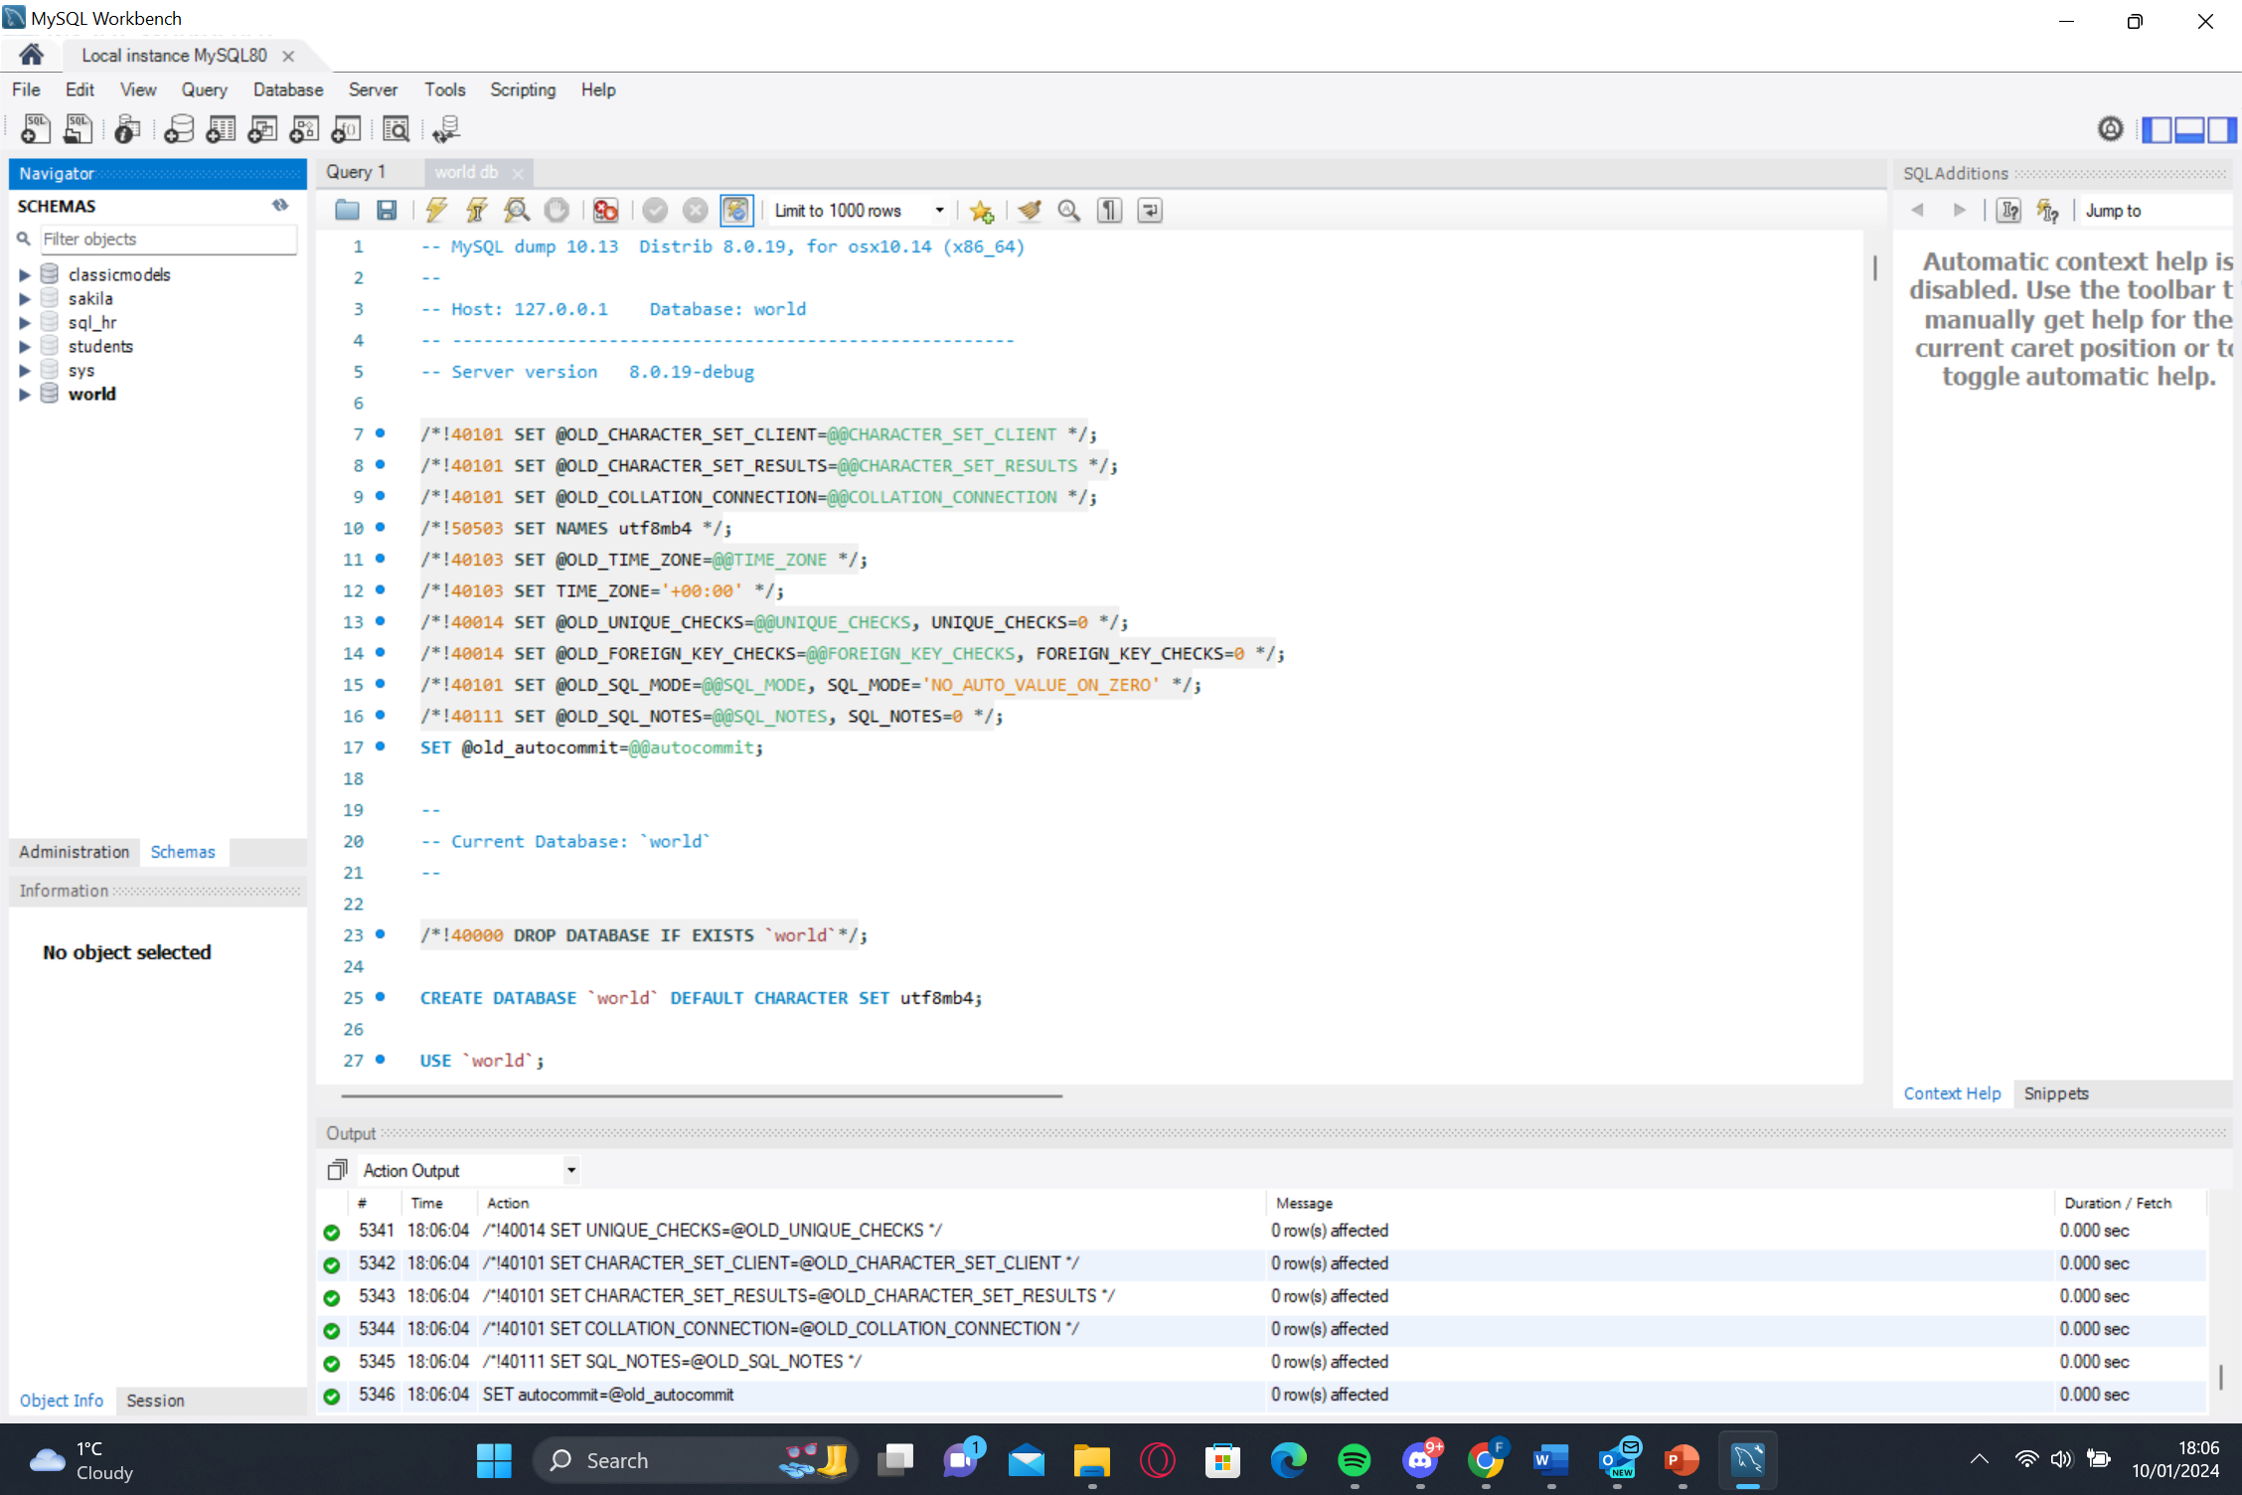

The first task of the assignment is to write a query using the count command to find the number of cites in the USA from the "world" database.

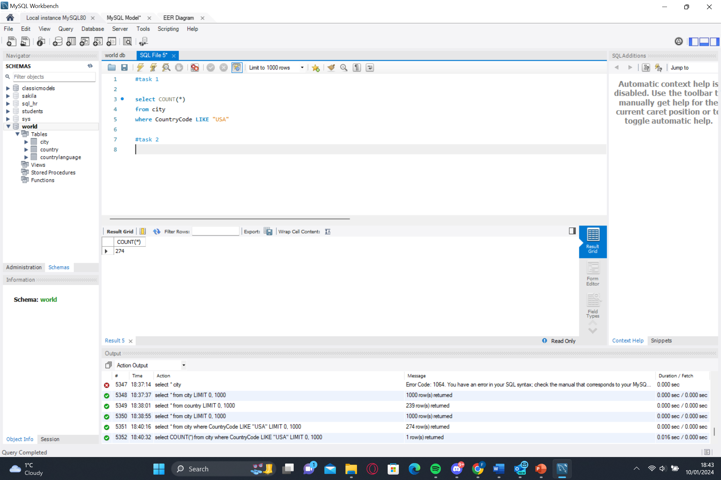

After executing the query, we got

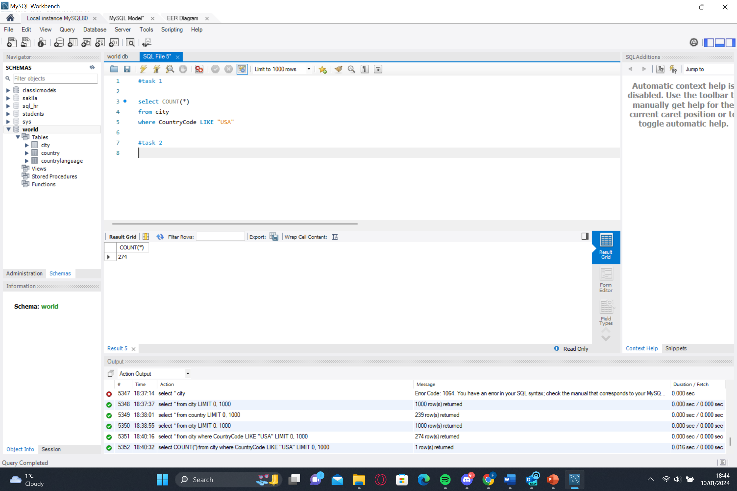

For the second task, I found out what the population and average life expectancy for people in Argentina (ARG) were.

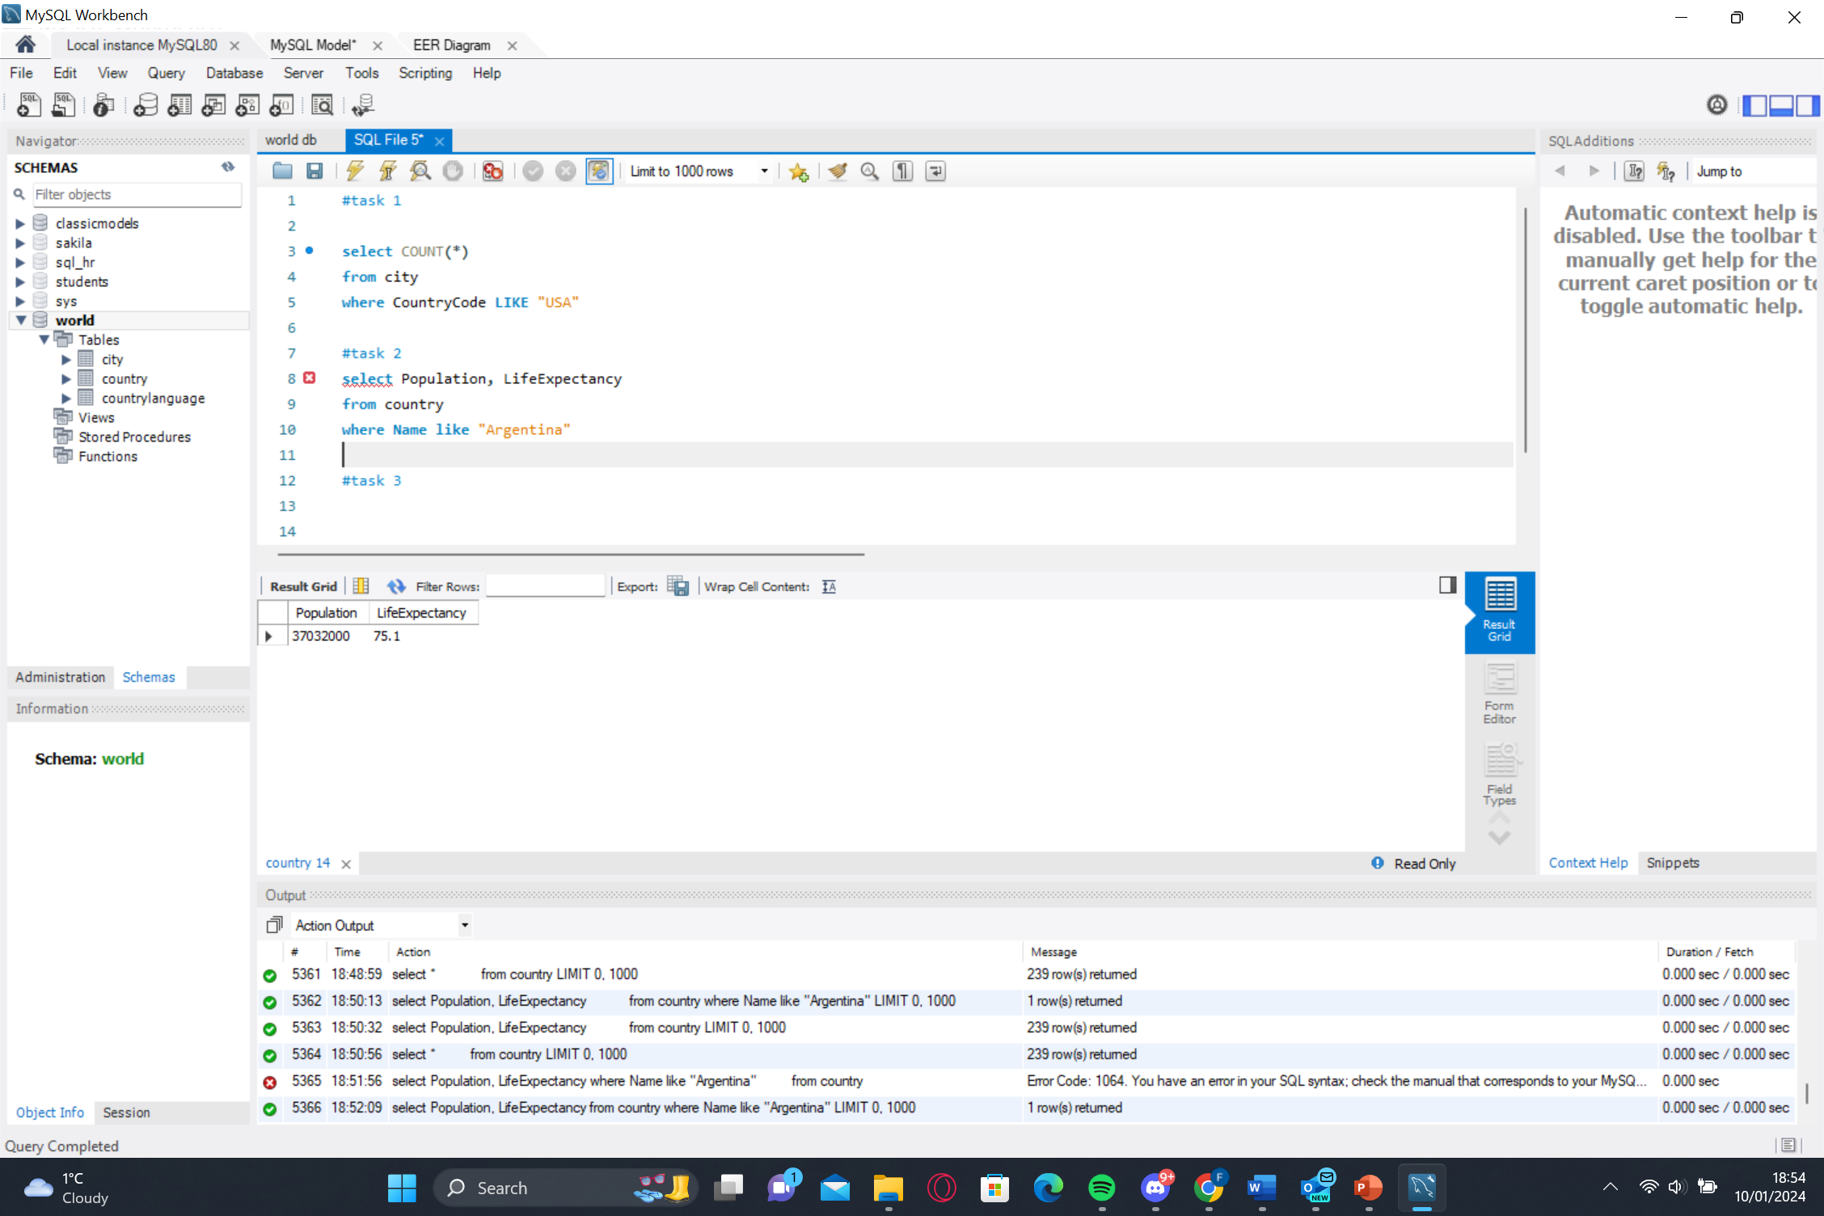

After executing the query, we got

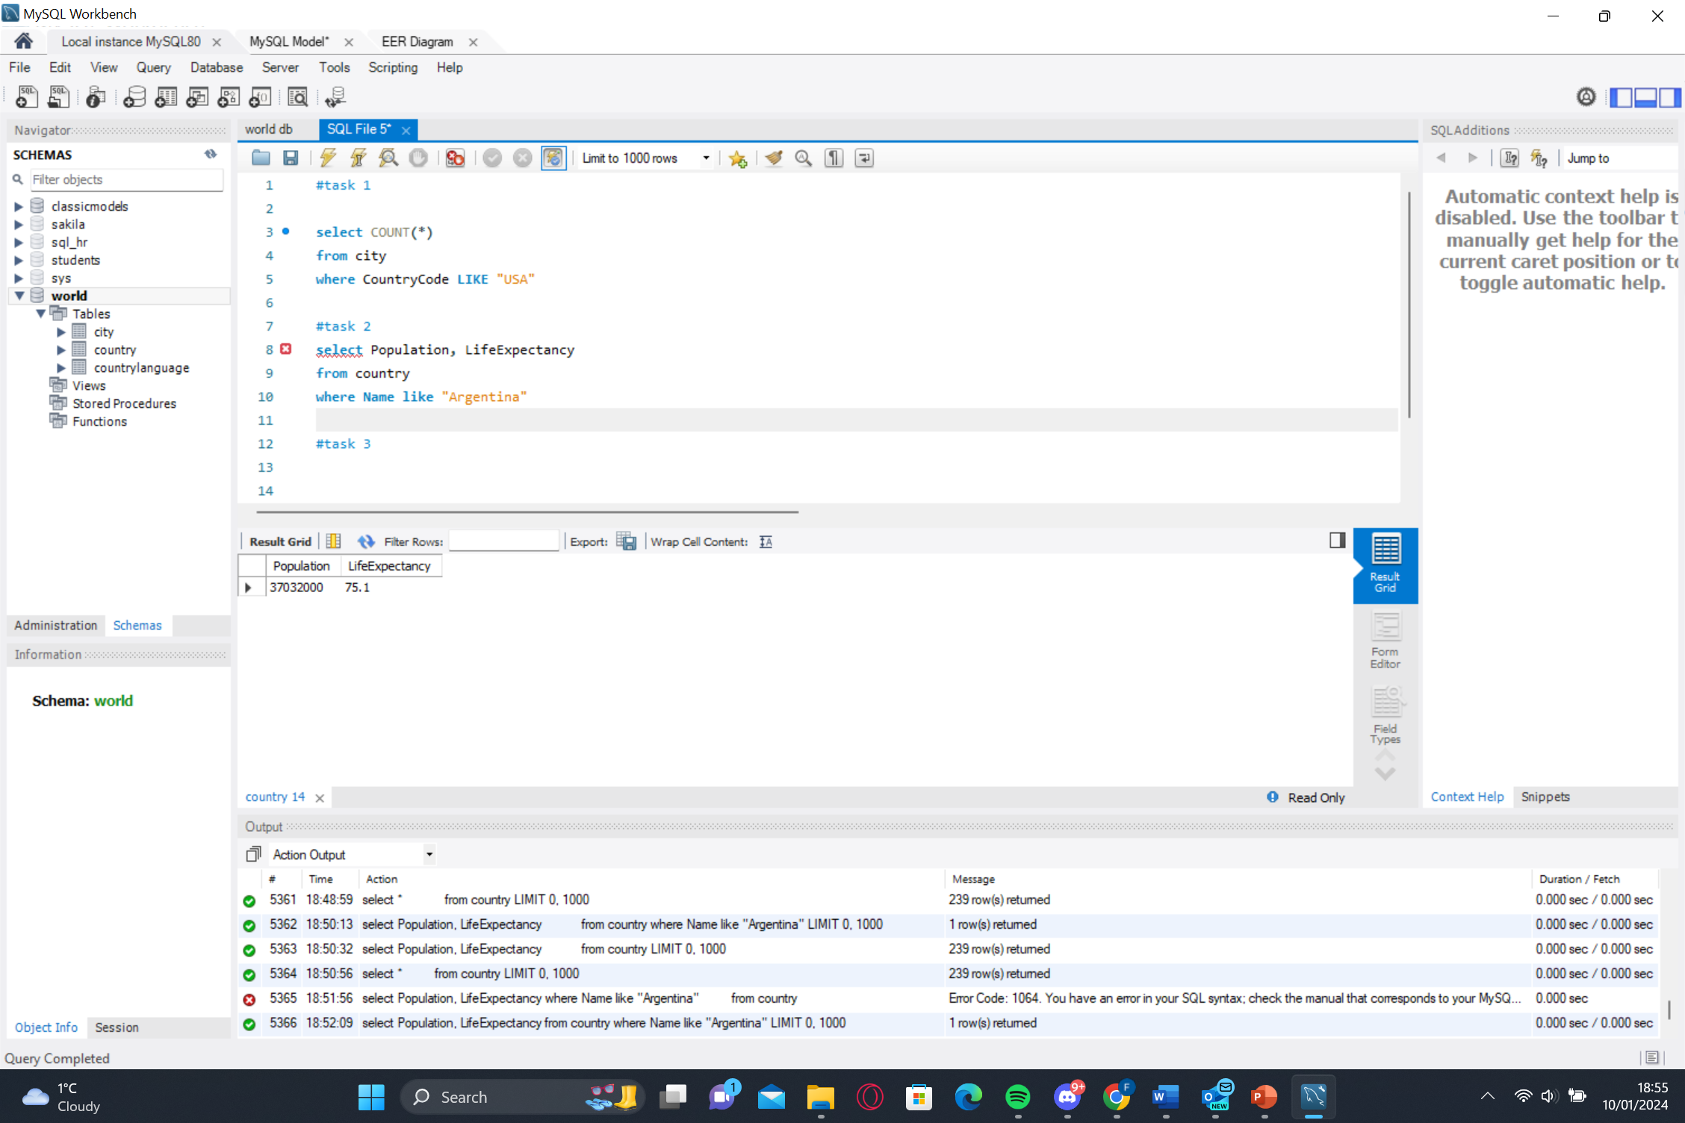

For the third task, I used ORDER BY and LIMIT to determine which country had the highest life expectancy.

For the 4th task, I wrote a query that selected 25 cities from around the world that had started with the letter ‘F’.

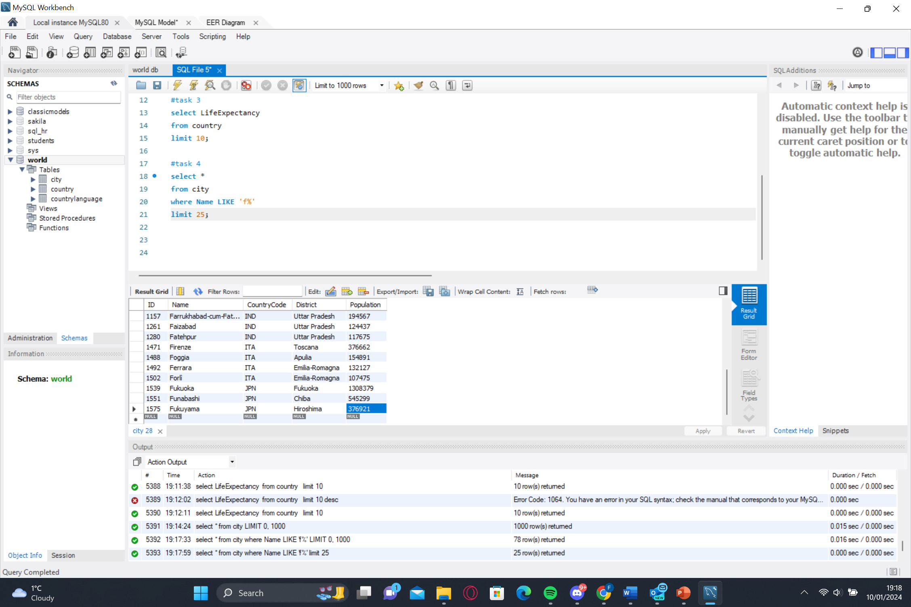

After executing the query, we got



For the 5th task, I created a SQL statement to display columns Id, Name, Population from the city table and limited the results to the first 10 rows only.

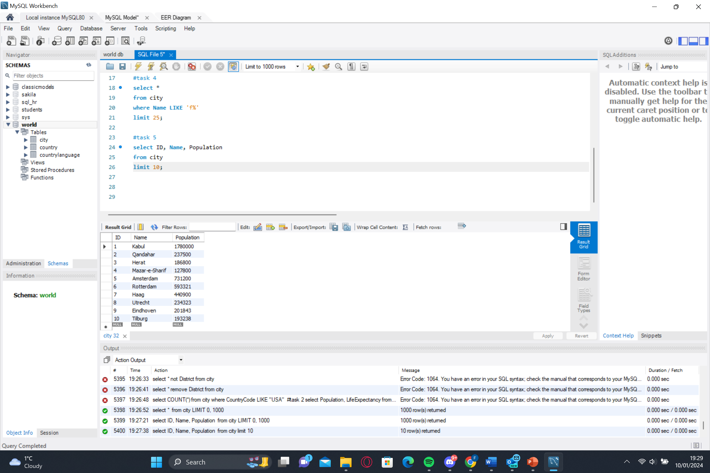

After executing the query, we got

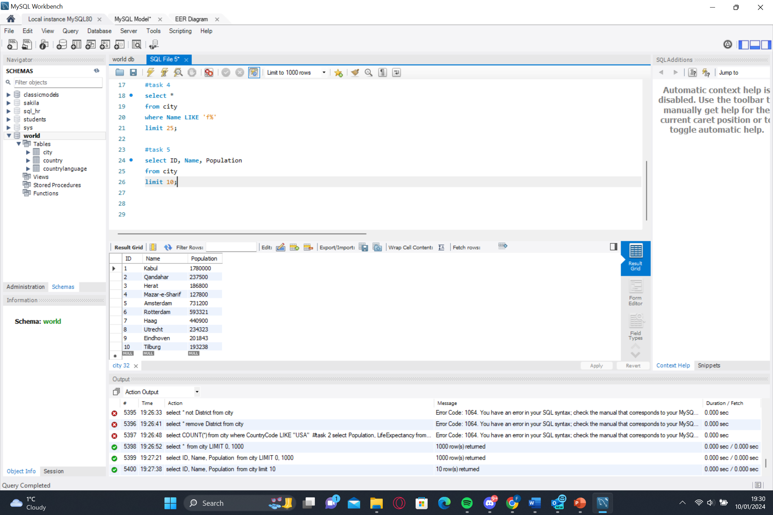

For the 6th task,   
I created a SQL statement to find only those cities from the city table whose population was larger than 2000000.

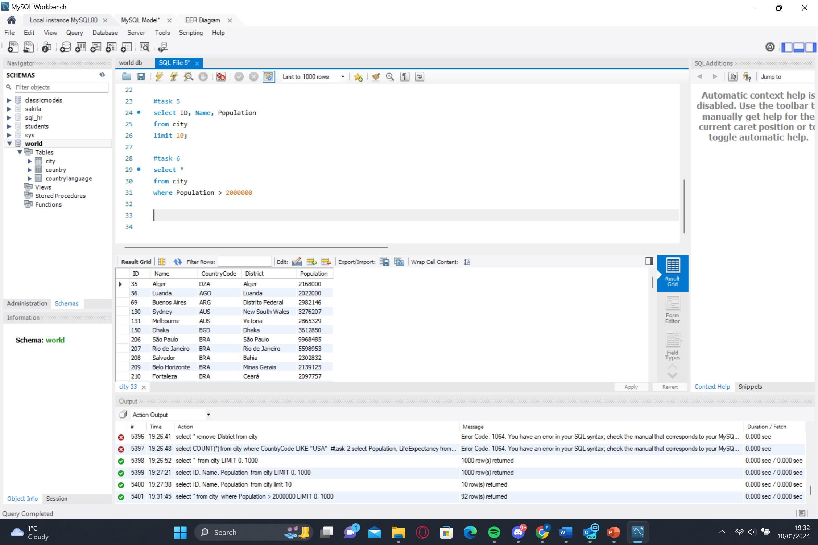

For the 7th task, I created a SQL statement to find all city names from the city table whose names began with the prefix "Be".

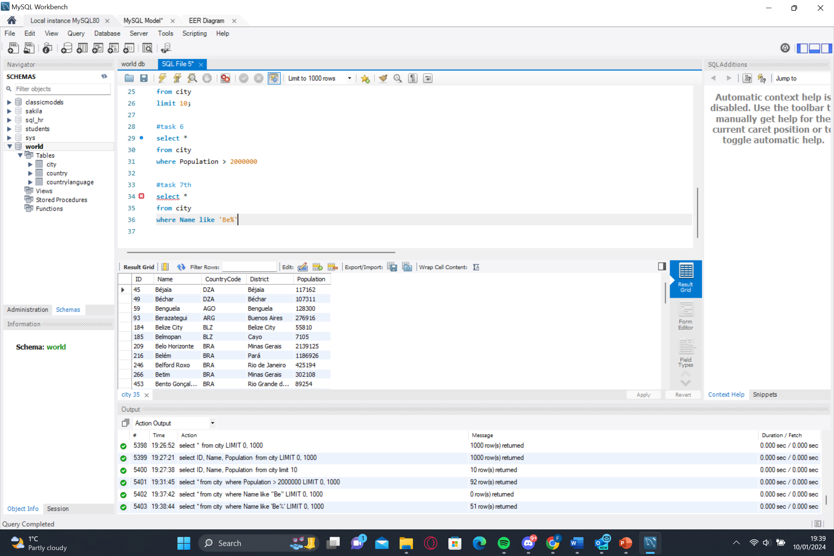

For the 8th task, I created a SQL statement to find only those cities from the city table whose population was between 500,000 and 1,000,000.

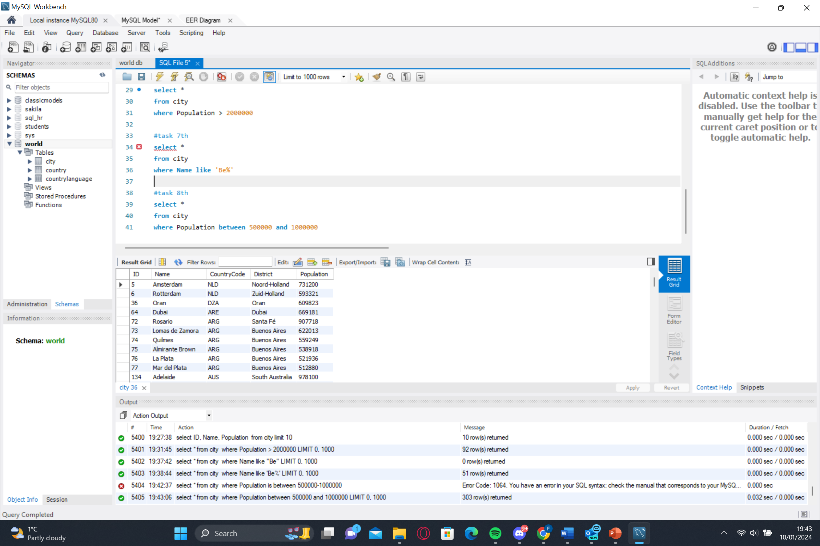

For the 9th task, I created a SQL statement to find a city with the lowest population in the city table. As you can see below; Adamstown is the lowest population with only 42 people

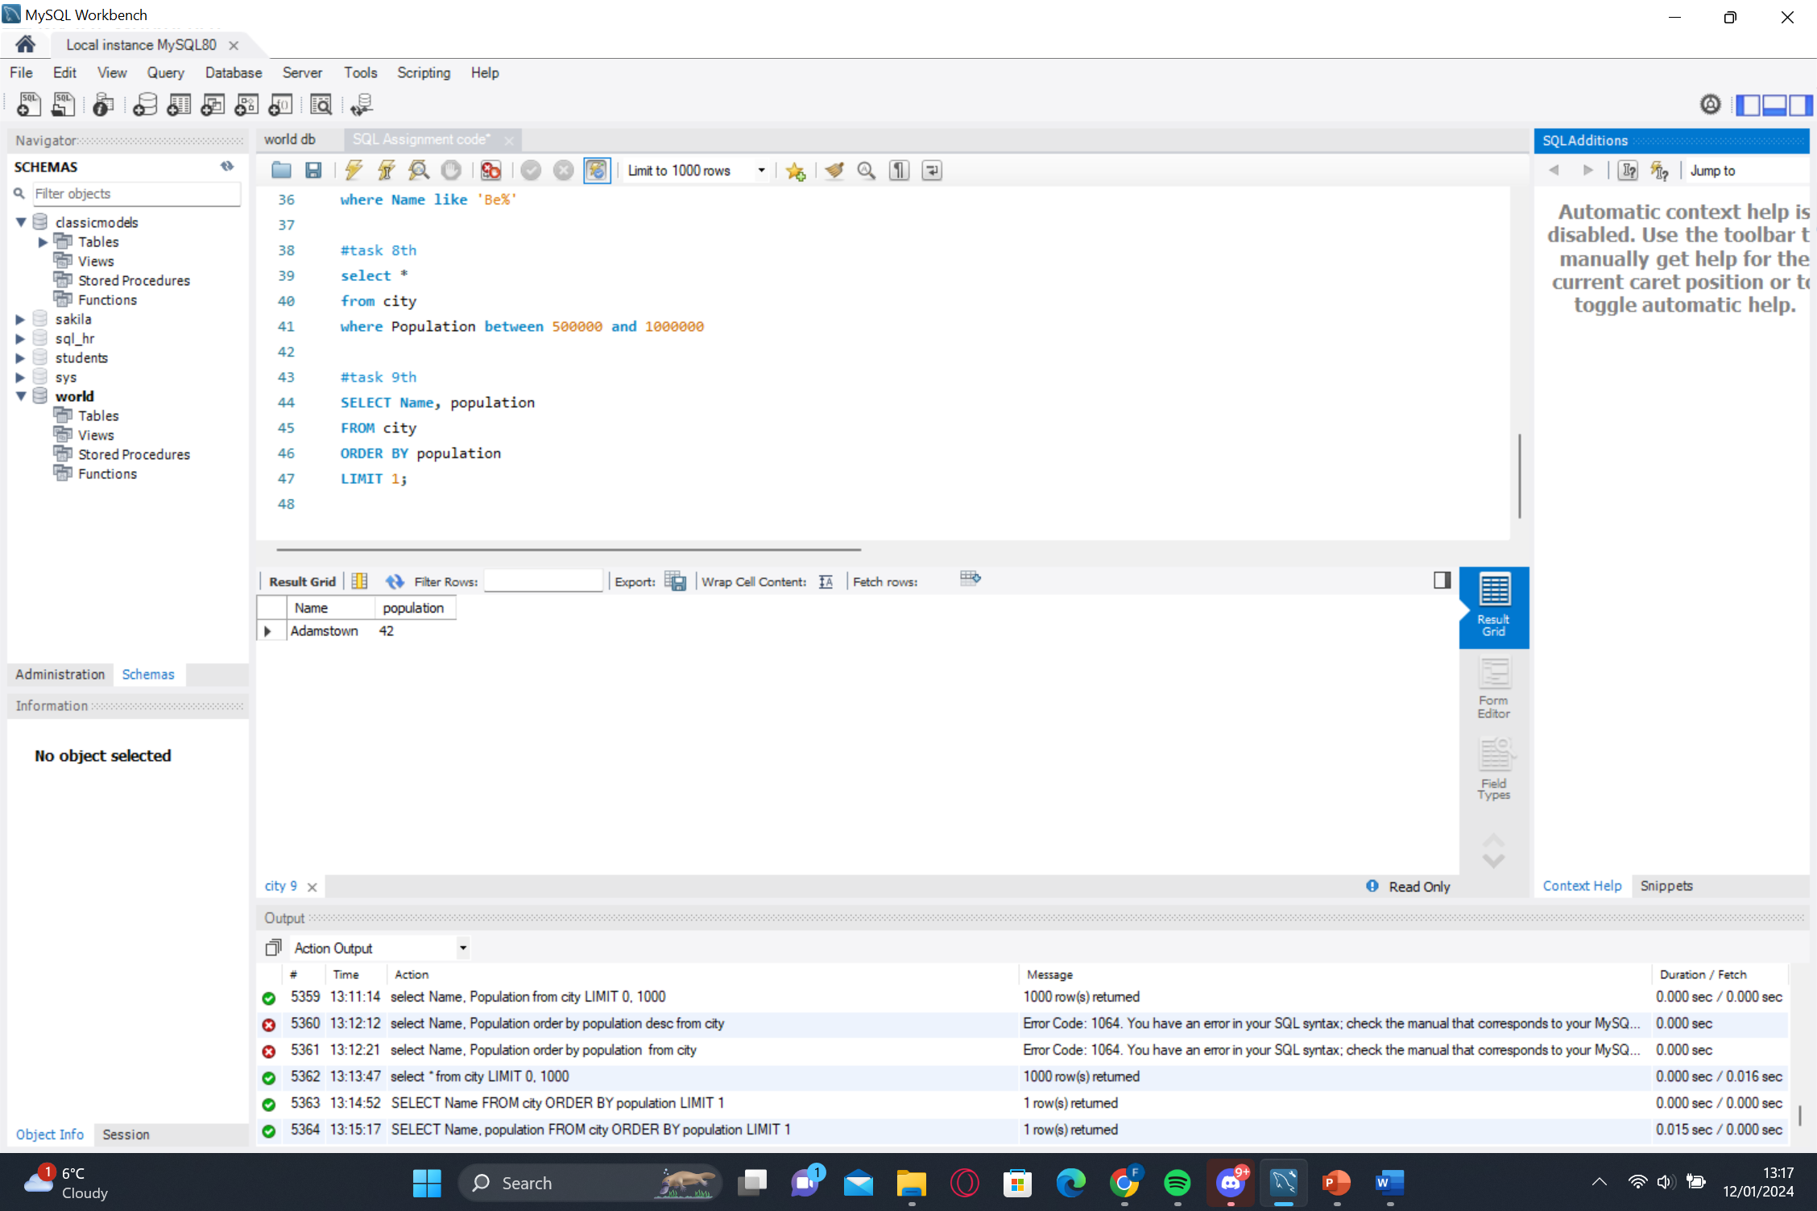

If you look at the relationships between all the tables. We can see that the foreign key for both the countrylanguage table and the city table is CountryCode

